# Chapter-6: Other Project Issues

Developing any project start with different problems and issues. At the very beginning from proposal to requirement gathering, designing, implementation, testing, and final documentation many problems and issues arise. Tackling and handling those issues to move ahead and to complete the project was the aims.

## 6.1 Other project issues in the projects

Some of the issues and problems that I faced during completing projects are listed below:

* Doing a project in java:

First and greatest issues in my projects because I was trying to do my project in whole new programming language for me that is java.

Solutions: To solve this, I have studied online and got some help from teachers and my seniors.

* Limited time:

As there will be always a limited time to complete any projects but for me, this becomes more challenging because on one side I have to learn java which is new for me and whereas in another hand I have limited time to complete.

Solutions: Working hard and getting help from teachers and seniors help me to solve this.

* Junit testing

As Java was a new language for me, JUnit testing also new for me which becomes challenging issues for me to do JUnit test in my projects.

Solutions: Searching online and getting ideas from teachers help to solve this problem.

* Other issues

Different other issues like a relationship in the final class diagram, database design, drawing a static and dynamic diagram and other small issues came arising which constantly make me difficult to complete projects.

Solutions: To solve this, gets help from a teacher and read online.

## 6.2 Project Limitation

In the process of completion, many things need to be taken into consideration and many problems and issues arise. Due to this reason some of the project limitations arise which is given below:

* Online payment:

Customer cannot pay bills online of their order tiles because as it requires more technical integration knowledge, skills and needs to assure card data security.

* Integration with other apps

Customer cannot integrate their account with other social media apps like Facebook, Instagram, and Twitter because of lack of knowledge and inexperience.

* Order confirmation

As an online ordering website much online order will be made but to confirm those order whether it is fake or not admin need to manually call to provided phone number during making an order. It can’t be done because of the limited time constraint.

## 6.3 Future Work

In the process of completing any project problems, error, issues and other barrier arise that result to exclude other functionality and features which make the system more user-friendly, efficient and easy to use. So, some of those features and functionalities which will be included in future work are given below:

* Online payment:

Including online payment in the system make more easy and efficient to pay bills by the customer and as well as for the company.

* Order confirmation

Integrated this in the system will help the company staff to confirm the order of the customer easily and effectively.

* Multi-language system

Making the system multi-language will not only make user-friendly but also encourage and make the different language of people to use the system.

## 6.4 Risk Management

The way of managing conditional or unconditional risks that directly and indirectly affect developing system called risk management. During the development of project many new and old risks were found. some of them are listed below with their mitigation.

|  |  |  |
| --- | --- | --- |
| S.No | Risks | Mitigation ways |
| 1 | Data Breach | During the development to handle data breach strong rules and policy is implemented. |
| 2 | Hardware failure risk | To mitigate hardware failure data is back up in different ways. |
| 3 | Legal risk | Knowing there can be a legal risk, the system is developed considering rules and regulation of government. So as to tackle this risk |
| 4 | Functional and performance risk | Being limited time to complete there can be bugs in functionality and slowness in performance. So it has been tackled by doing both black box and JUnit testing |
| 5 | Schedule(time) risk | To manage this risk I have prioritized functionality and feature, followed SSADM method to complete the project in time. |

## 6.5 Configuration Management

Configuration management is the collection of activities, tools, processes, and methods. That can be used by project practitioners during the project life cycle to manage items.

As for backup of my projects. I have backup online in Github with the name of @Binodmagar. I have also backup my project to google drive.

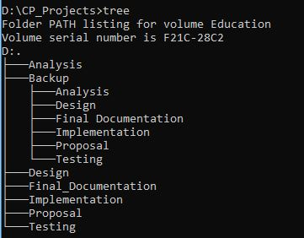

## 6.6 User Manual

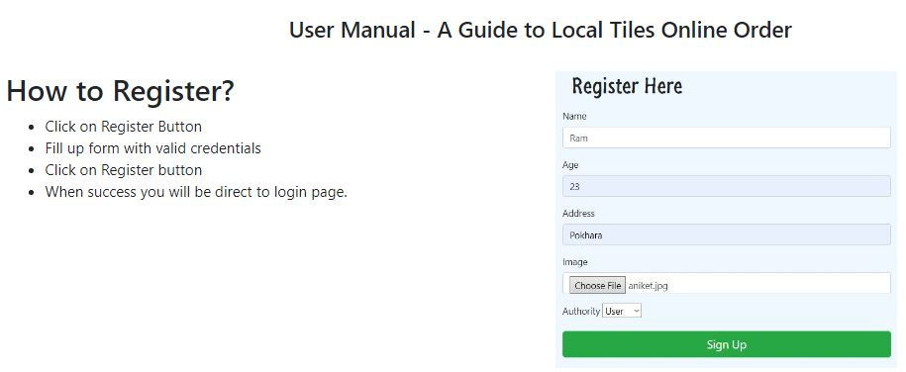

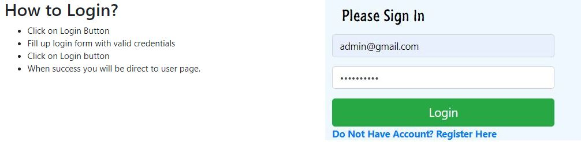

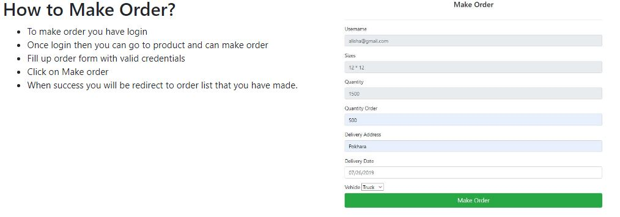

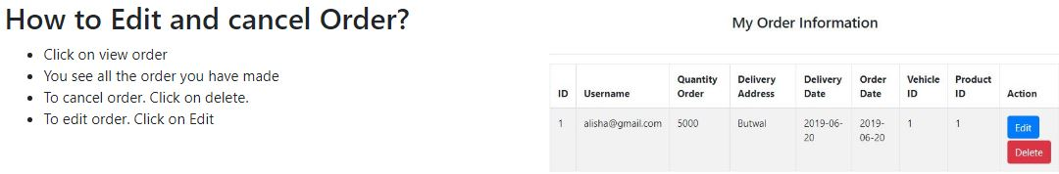

# Conclusion

The project starts once the proposal is accepted. Then as the software development methodology, Structured System Analysis and Design Method(SSADM) and its phases stated in the proposal. I started further development of the system.

The first phase was analysis where the requirement of the company was gathered, feasibility study of time, cost and resources are done to make sure that the developing system is feasible for the company, to show use-cases of users and admin use case diagram is done and architecture of the system is made.

After analysis, the design phase is done where how the system work and look is showed by making the structural, behavioral and user-interface design. Then in the implementation phase, I change the design phase into an actual product along with database build of the system. once implementation finished, testing of the developed system comes which is considered as an important phase in the SDM. In this phase testing like black and JUnit test is done of the developed system to ensure that there is no more bugs and problems in the system.

During completion of the system and all phases of software development methodology many small and big problems were faced, some of them are tackled by myself and some were by the help of teachers and online study. Overcoming all the problems and issues overall system is developed within a given time which meet the requirement that has been stated.

Appendix

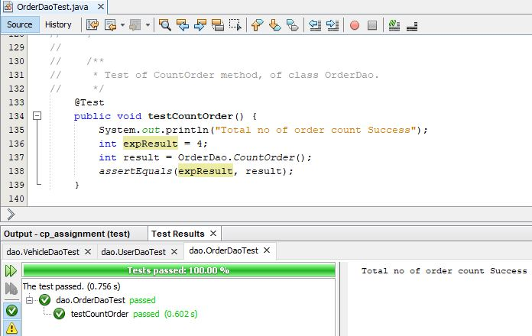

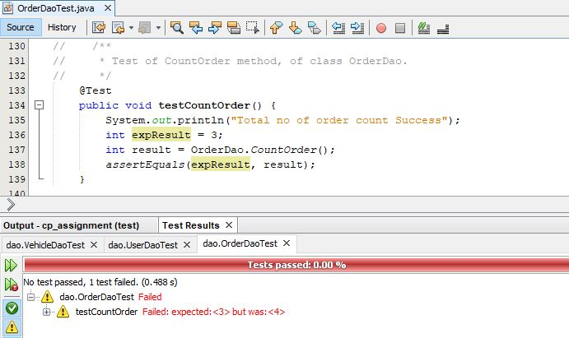

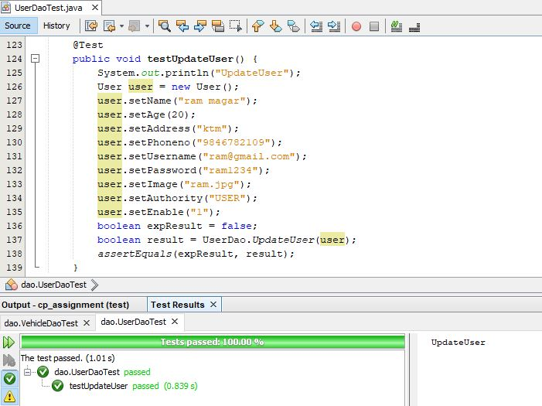

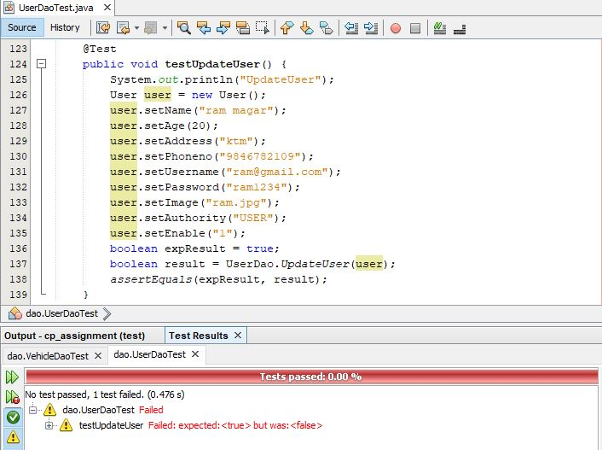

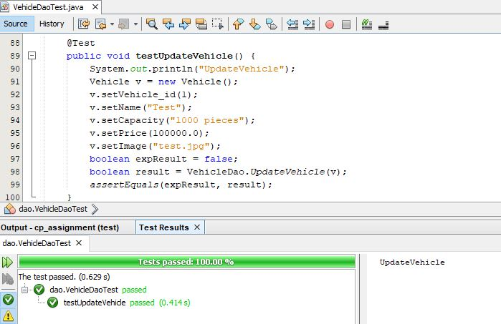

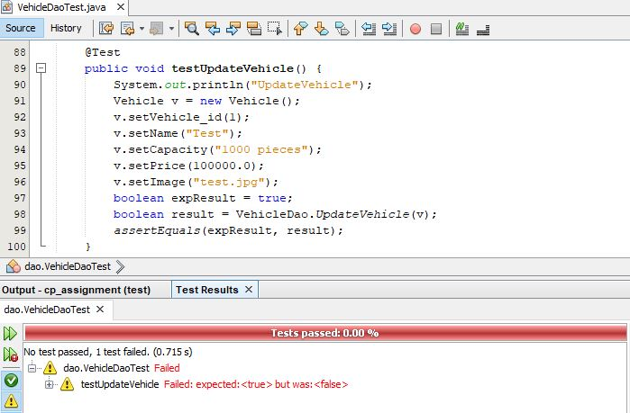

Abstract

Local Tiles Online Order is a web-based system developed to increase the productivity of the company and to achieve greater user satisfaction in ordering products. In this system, a customer can view all the information on products and vehicles that are available in the company. To perform other functionalities like make and manage orders, manage profile users need to register and login to the system. whereas on other side company staff manage all details of products, vehicles, and users. They also manage order and dispatch orders as per provided information once order confirmed.

This project is completed(developed) under Structured System Analysis and Design Method which is a hard approach method of software development. Under this methodology, different phase like analysis, design, implementation, and testing is included. The first phase analysis where requirement gathering, feasibility study, use-case and architecture of the project is done. The second phase was a design where structural, behavioral, and user interface design is included to show how system work and look. Then after finishing the design of the projects, it further converted into the actual product in the implementation phase. Where the database build is also done. To ensure delivery system meet the requirement dor exception and prevent system form bugs and issues in future two types of testing i.e black and unit is performed.

Finally, under phases of Structured System Analysis and Design Method(SSADM) of software development methodology project is completed within a given time that meets the requirement or expectation of the company.

Acknowledgment

During the completion of the project, I had faced many small and big problems that directly and indirectly stop me to further my development of the project. So I have to take advice(instruction) and help from relevant teachers to whom I gave my deepest gratitude. As finishing projects taught me more lesson and gave much pleasure, I would like to thanks Mr. Sudeep Lal Bajimaya who is Module leader of course for providing me a good direction and instruction throughout the projects. I also like to give my deepest gratitude and respect to Mr. Pratik and Achut sir who constantly help whenever I need.

I also thank my friends and classmate who provide me valuable suggestion and comments on my project which gave me the knowledge and encourage me to improve my projects.